**A quick explanation of the diagrams included in the project.**

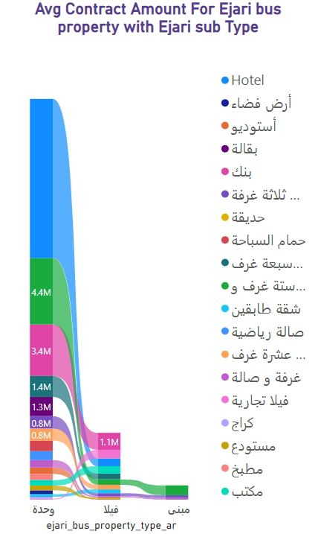**------------**

**This graph shows the relation between Ejari sub property groups (including the Type of Ejari sub as legend) and its Avg Contract Amount.**

***Note: ”here I am applying filter on Ejari sub-Type”.***

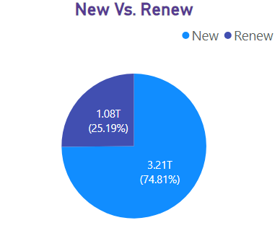

**This chart shows the total amount of contracts and percentage of sum for contracts, It helps to see the deference between New and Renew Contracts.**

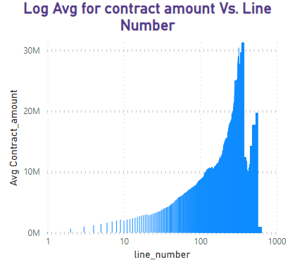

**In this graph, I am grouping the Contracts using its Line number then Calculating the Avg, also Applying on the “Line Number” logarithmic scale.**

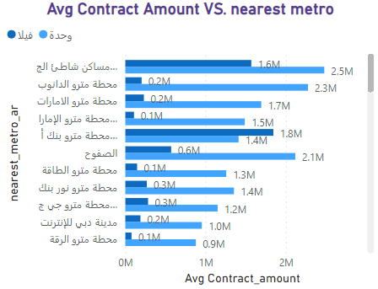

**This graph grouping contracts depending on nearest metro station and calculates average for it amount, also dividing these groups into two Ejari sub-type (Unit, Villa).**

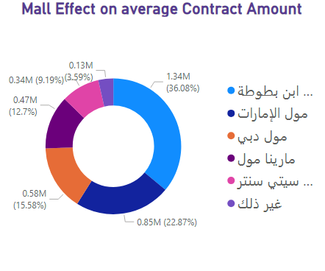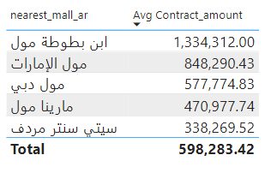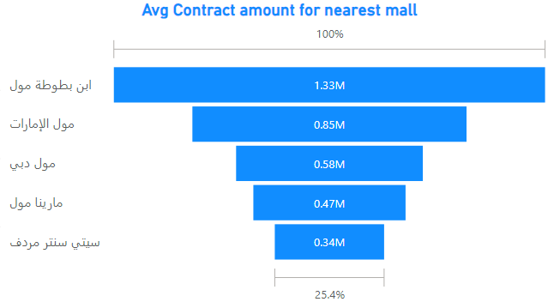

**👆These chart shows the mall's influence on the prices of contracts near it. 👆**

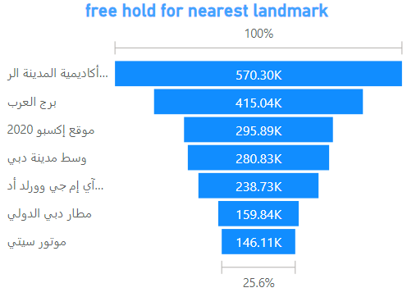

**In this chart, I grouped the contracts based on type (nearest landmark) and found the sum of total number for two types contracts (free hold and not free hold).  
*“Showing Just Top 7”***

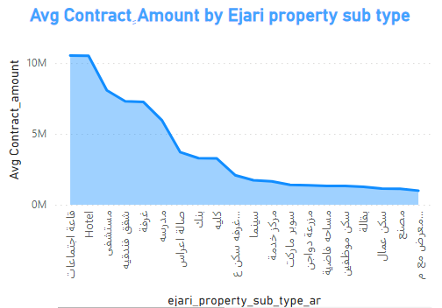

**In this graph, I grouped the contracts based on type (Ejari property sub-type) and calculate the Average of contracts amount, to show the deference between Contract Ejari property sub- type.**

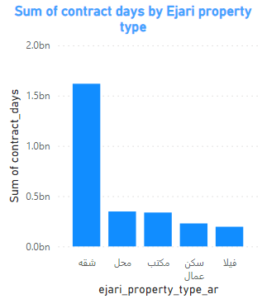

**in this graph, I found duration for every contract and collected contracts using Ejari property type.**

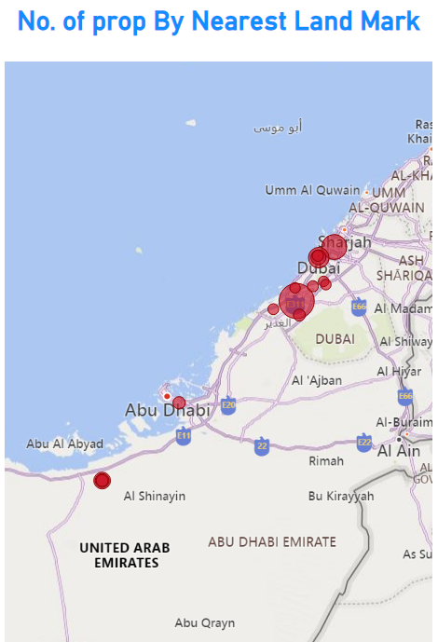**this map showing the location for Land Mark of contract and focus on No. Contracts for each Land mark.**

**“The Red Bubble for focusing on Numbers of contract in land marks”.**

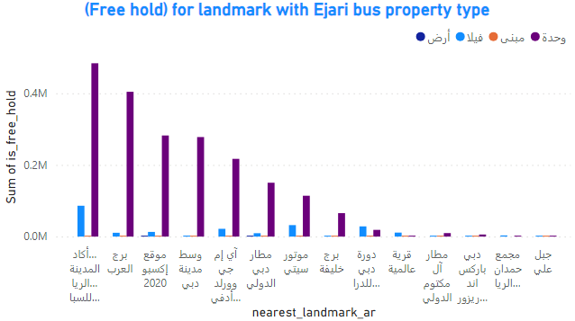**this graph shows Sum of free hold contracts after grouping it by landmark, also dividing the landmark columns to Ejari bus property types.**

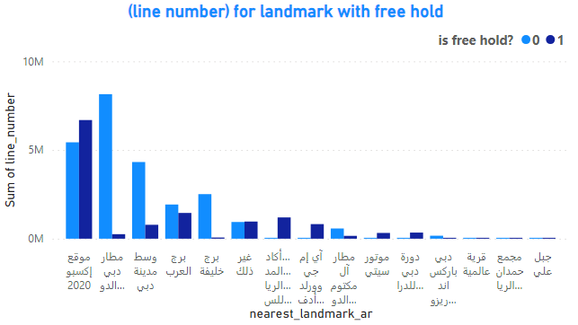

**This graph shows Sum of line Number for contracts after grouping it by land mark, also dividing the landmark columns to (free hold) status.**

***“1 : free, 0 : not free”***

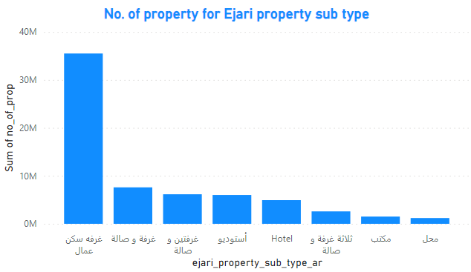

**This graph shows Sum of number of property contracts after grouping it by contracts Ejari property sub-type.**